# Yeast_ACDC Installation for MacOS:

1. Download Python 3.8.5 from here <https://www.python.org/ftp/python/3.8.5/python-3.8.5-macosx10.9.pkg>
2. Install downloaded Python with default settings
3. Download and install “GitHub Desktop” from here <https://desktop.github.com/>

|  |  |
| --- | --- |
|  |  |

1. Open “GitHub Desktop” and click on “Sign in to GitHub.com”. This will open a browser tab where you can Login to your GitHub account. **NOTE**: not all browsers are supported. Makes sure that you login onto a supported browser. This should not be a problem on MacOS with Safari or Chrome. I think the only one not being supported is Internet Explorer, but if your browser is not supported you will get a message. If the automatically opened browser is a non-supported one you have to change the default browser in your OS settings (in Windows type in the search “Default Apps” and change the default Web Browser) and the click again on “Sign in to GitHub.com” in “GitHub Desktop”. If the default browser was changed successfully now GitHub Desktop should open in the default browser.
2. If the login was successful, “GitHub Desktop” should now look like this:

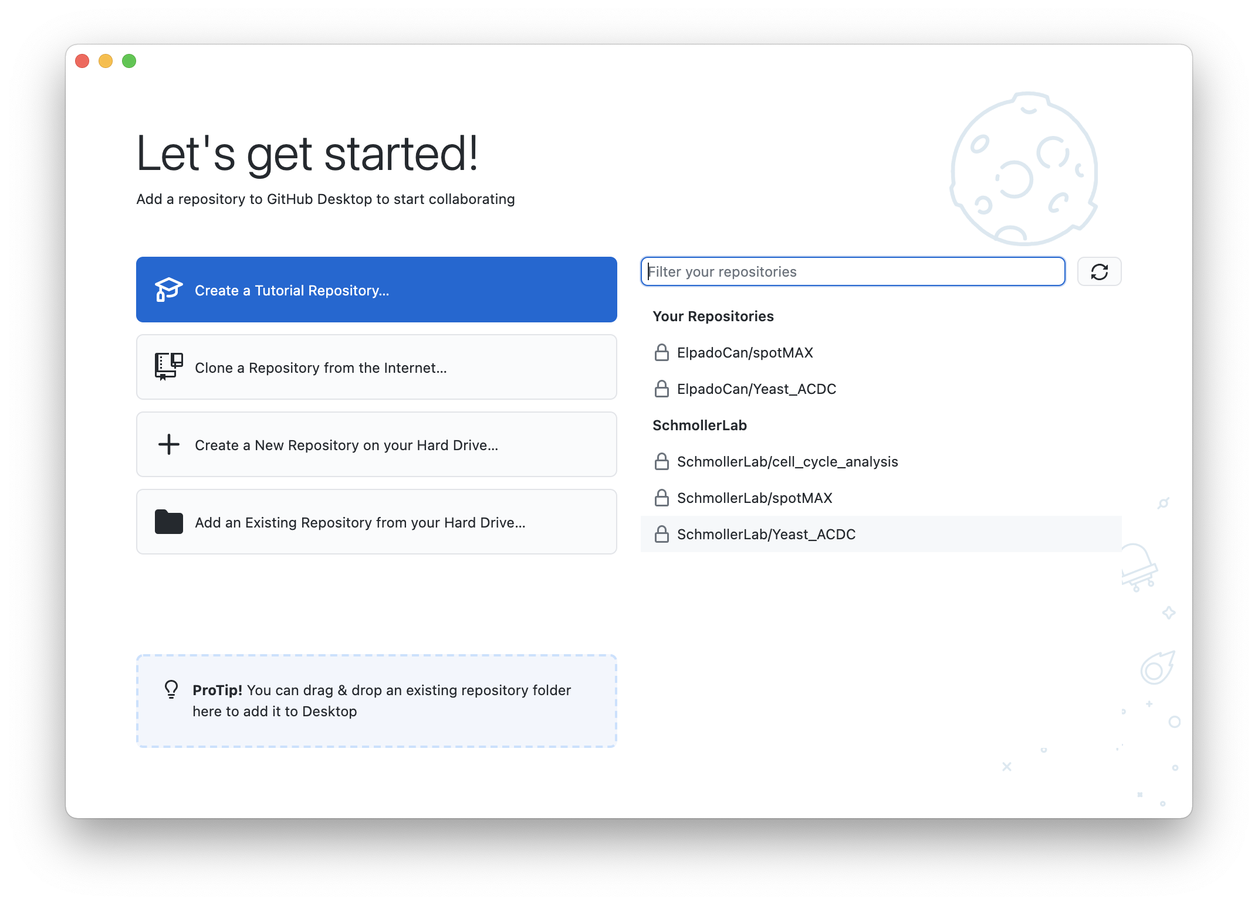

1. Click on “SchmollerLab/Yeast_ACDC” and then click on the button “**CLONE** SchmollerLab/Yeast_ACDC” (bottom-right)
2. In the “Local path” choose where you want to install Yeast_ACDC. The default one is fine.

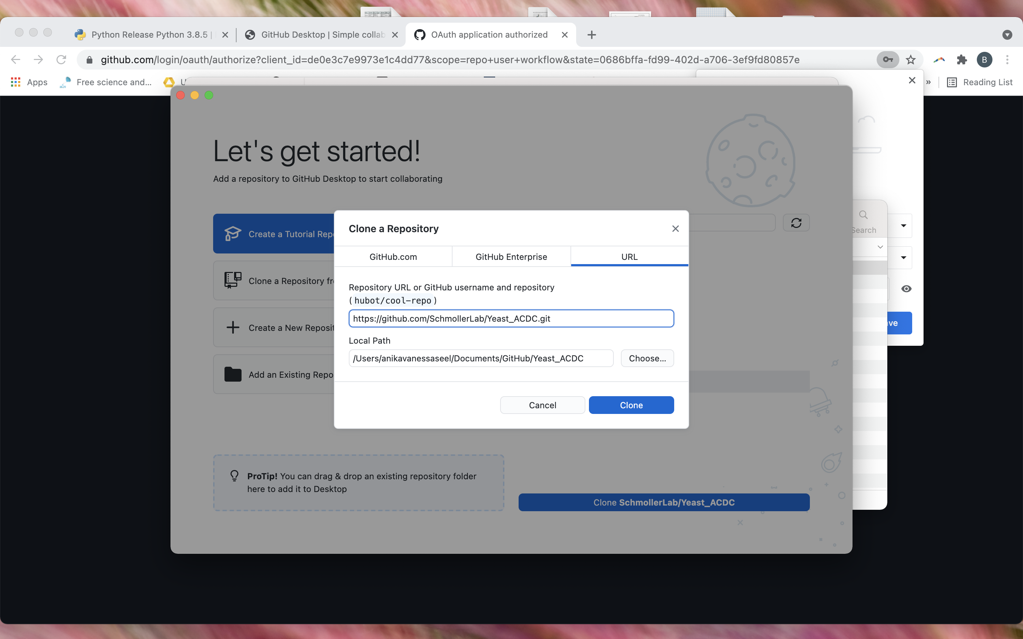

1. Close GitHub desktop
2. Open **Terminal** (Click the Launchpad icon 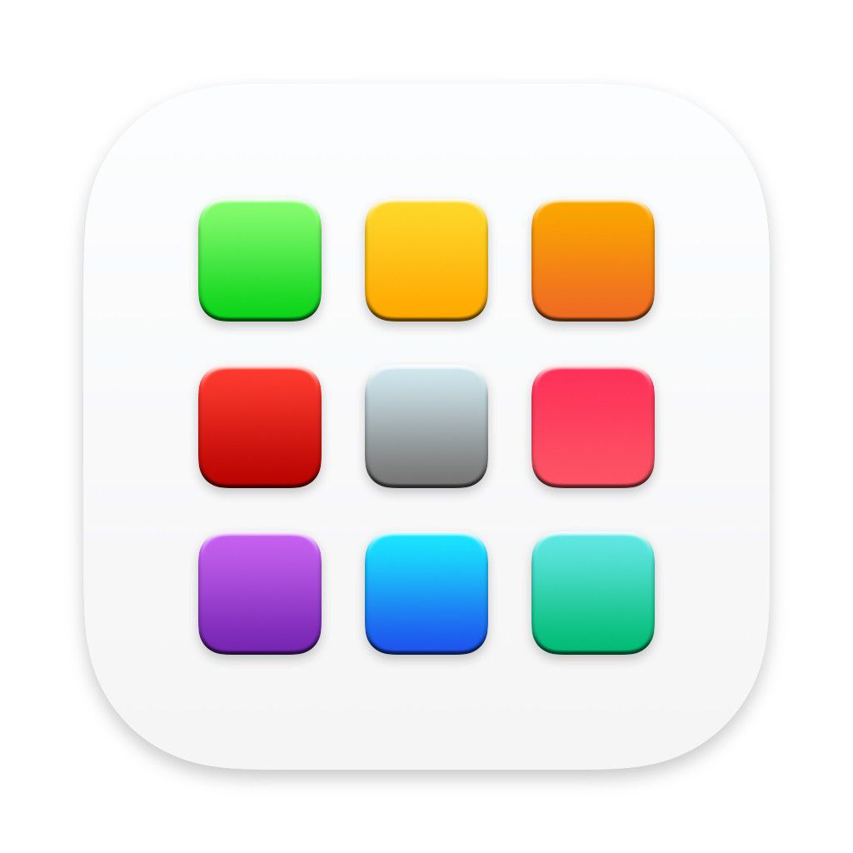 in the Dock, type Terminal in the search field, then click Terminal)
3. In the terminal navigate to the Yeast_ACDC folder with the cd command. In my case I have installed Yeast_ACDC (step 7) in “/Users/anikavanessaseel/Documents/GitHub/Yeast_ACDC”. When we open a Terminal in MacOS usually we are already in ““/Users/anikavanessaseel” so we only type cd documents/github/Yeast_ACDC (capital letters do not matter, you can type all non-capital).
4. Now we are ready to install the environment for Yeast_ACDC which are all the packages needed. Type the following commands one at a time:

python3 -m pip install --user --upgrade pip

python3 -m pip install --user virtualenv

1. If the terminal shows you the message

WARNING: The scripts pip, pip3 and pip 3.8 are installed in ‘some-path’ which is not in PATH

Then we have to add the path in the quotes to PATH. Copy that path and then type in the terminal sudo nano /etc/paths then paste the path at the end of the file and press “control+x” and then accept the saving with “y” and press “enter” to exit. See screenshot below

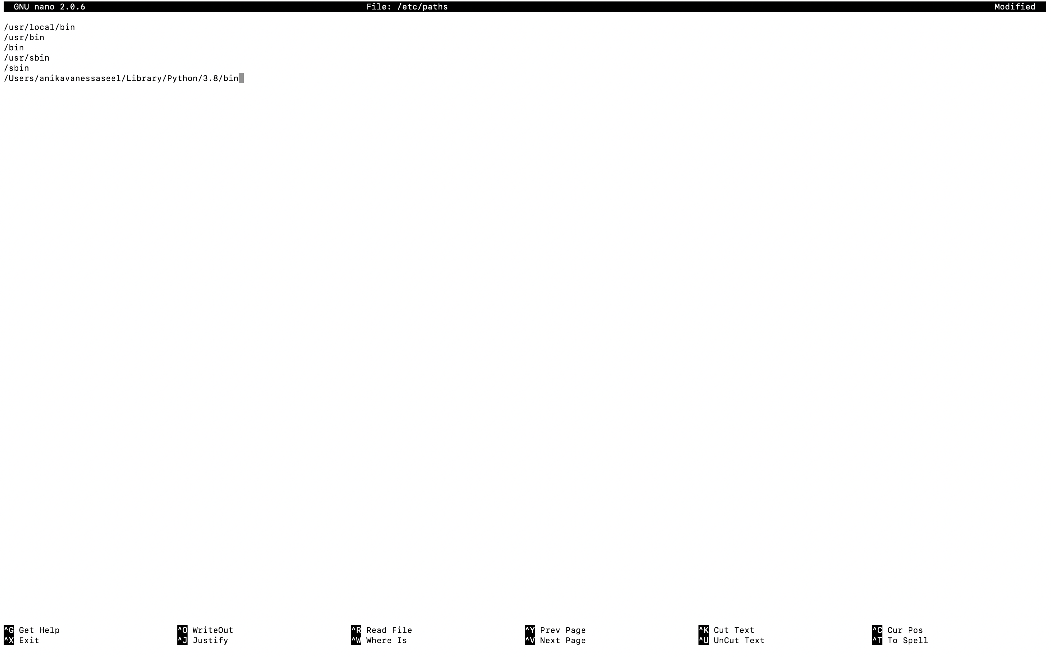

1. You should now be back in terminal (make sure you are in the Yeast_ACDC folder as explained in step 10.) and we can finish installing Yeast_ACDC environment. Type the following commands one at a time:

python3 -m venv env

source env/bin/activate

python3 -m pip install -r requirements.txt

Now you will see several packages being installed. It will take several minutes (around 20 if I have to guess) depending on the speed of the internet connection. This is how my terminal looked like after the sequence of commands (it is installing the packages)

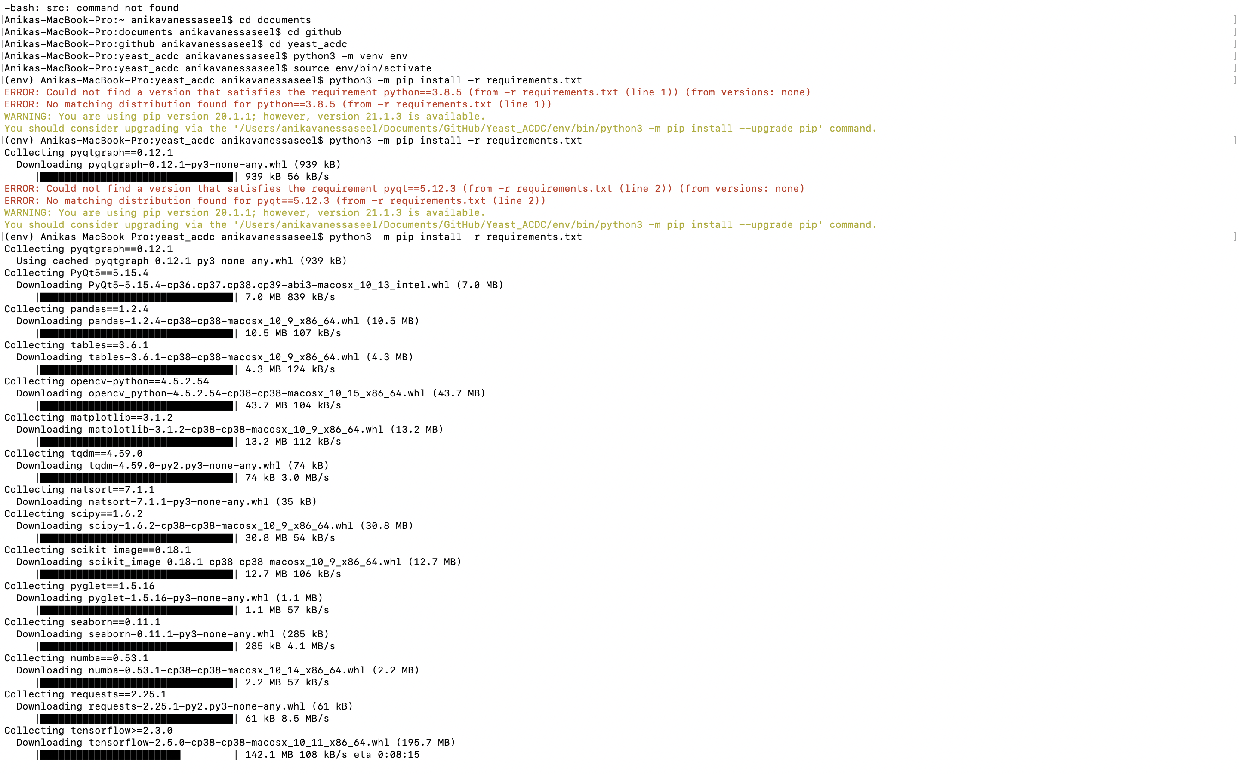

# Preparing your data for Yeast_ACDC:

1. Yeast_ACDC automatically upload all the data it needs, but it needs it with a specific structure. To facilitate the creation of this structure we provide Fiji (ImageJ) scripts that automatically structure the data from any microscopy file (.czi, .nd2, .tif etc.). So first of all, if you don’t have it install Fiji from here <https://imagej.net/software/fiji/>
2. Extract the content of the downloaded Fiji folder and run “Fiji.app/ ImageJ-win64”
3. File 🡪 Open and select either “frames_to_tifs.ijm” or “snapshots_to_tifs.ijm” file from “/Yeast_ACDC/FijiMacros/” folder.
4. Before running the macro you have to edit the channels. At line 3 of modify the “channels” variable by writing a name for each channel in your file. They need to be in the exact same order they are in the original microscopy file. If you don’t know the order, open the file in Fiji first and check the order of the channels there.
5. Run the script with the Run button. The script will ask you to select a folder containing the microscopy files (create a specific experiment folder for each different set of files). Select the folder (it MUST contain ONLY the microscopy files) and wait. You can see the progress in the Log Window. The script will silently open the microscopy files and save each Position (if the file contains multiple positions) into a separate folder. This is the structure that Yeast_ACDC requires for automatic loading of the relevant files.

# Running Yeast_ACDC:

1. To run Yeast_ACDC open a Terminal window. Navigate to Yeast_ACDC folder as in step 10. And then type source env/bin/activate
2. Navigate to src folder (Yeast_ACDC subfolder containing the scripts) by typing cd src
3. Now we can run Yeast_ACDC by typing python acdc_yeaz.py or python gui.py